Administrator’s Guide

**INDEX**

Introduction………………………………………….………page 2

Web page requirement……………………………………page 3

Enter the administrator page………………………..……page 4

admin registration…………………………………….….…page 5

what an administrator must fill………………………….…page 6

Administrator’s Guide

Introduction

the administrator guide has the objective of systematically explaining the function that an administrator can have within the application, at the same time understanding how it works and what can be modified as an administrator.

Administrator’s Guide

Web page requirement:

1. The website can run on the following browsers.

* Google Chrome.
* Microsoft Edge.
* Internet explorer.

1. The minimal screen size of 15.6 inches and resolution 1080 x 720

Administrator’s Guide



When starting the web page it will load the user login, at the bottom there are three options, which the administrator can choose between two to enter the main page, they are "register as a company" or "enter as a company", the first option is to create a new administrator.



Options for administrators

Administrator’s Guide



To register an administrator, the form must be filled out with basic information, to later fill out something more extensive and manage what can be seen on the page.

Administrator’s Guide

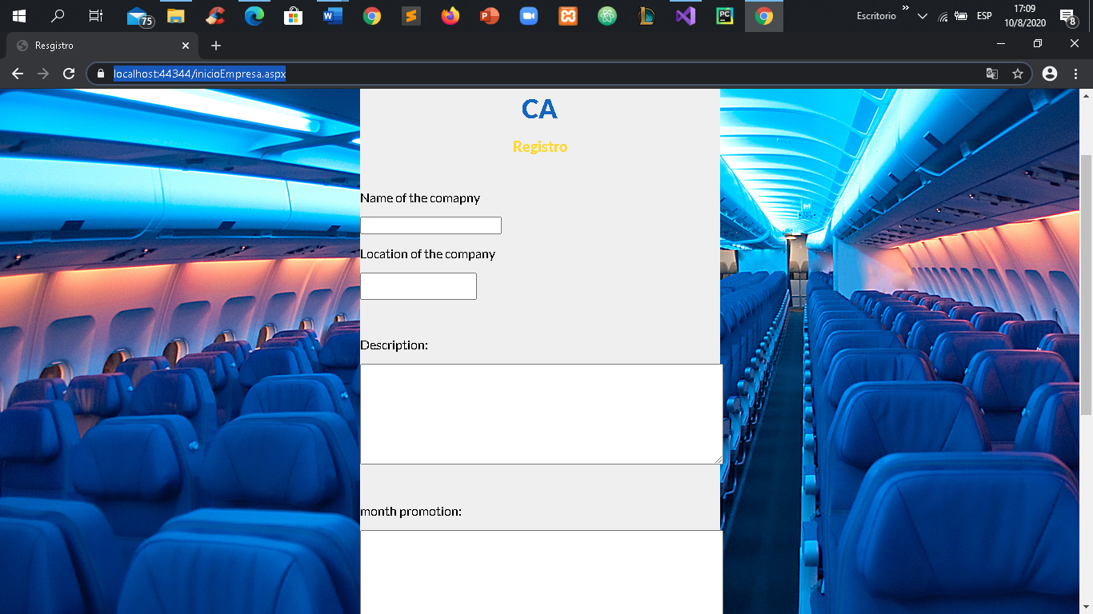

In this part the main information of the company is filled, which will be used to store and have the reference.



Here they will put the data that can be shown to the client. After creating all these fields, what has been put in each one will be shown on the main page for users.